**Task Scheduler cron job Window 10**

1. First search task scheduler:

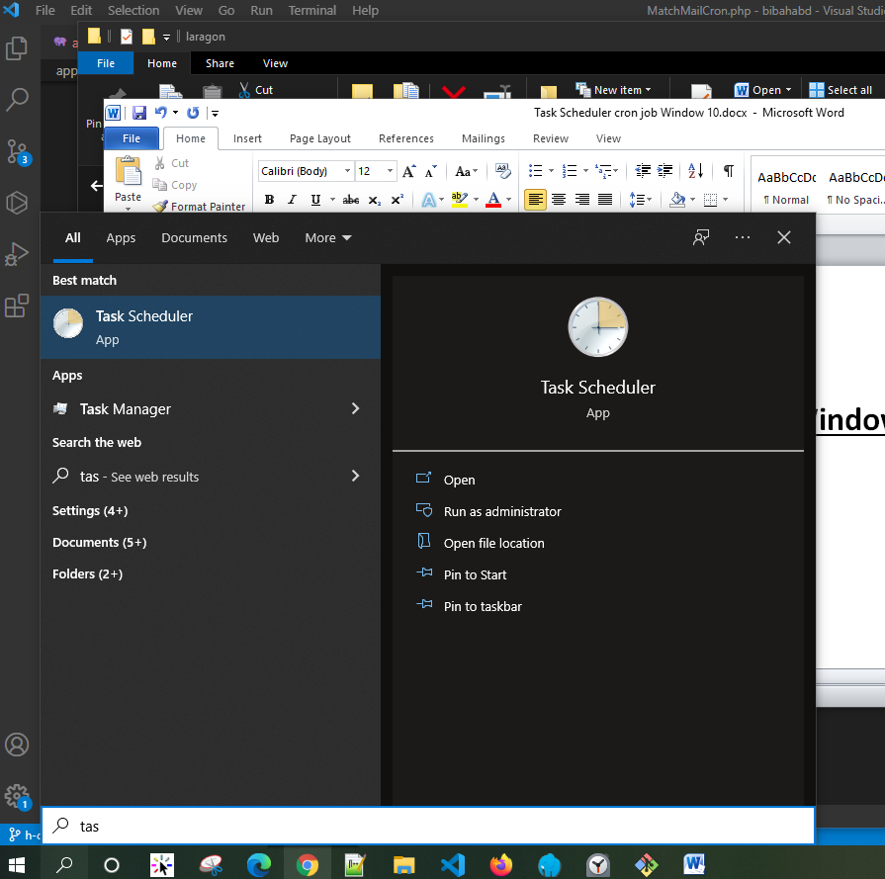

1. Create Task

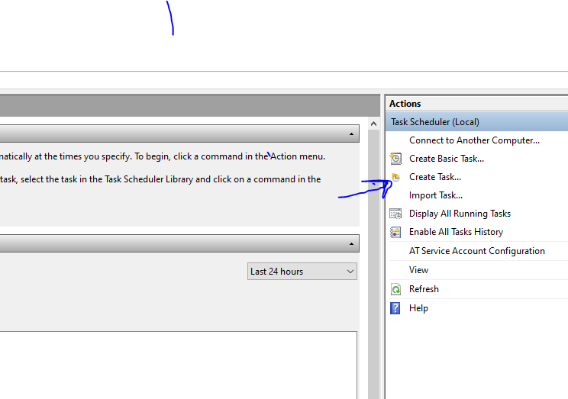

1. 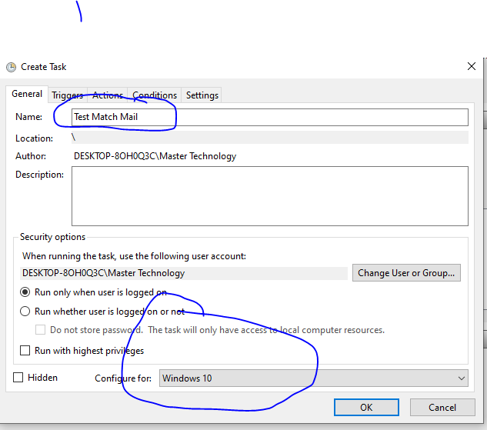

4)

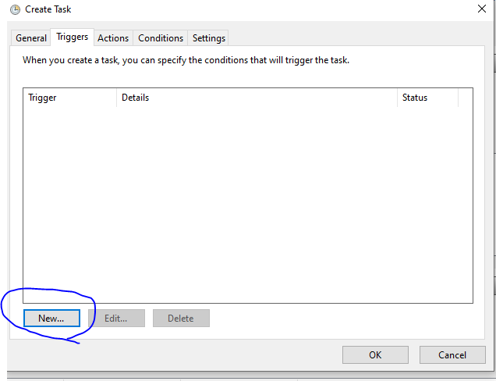

5)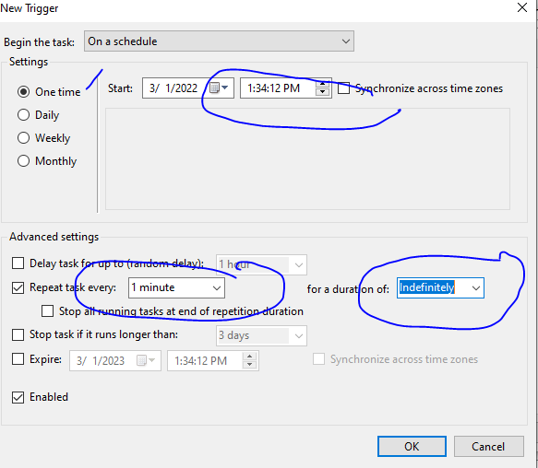

6) 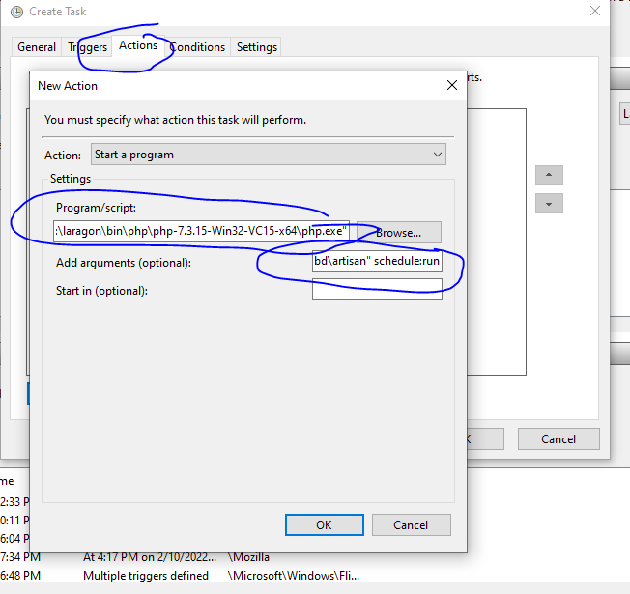

Script: "C:\laragon\bin\php\php-7.3.15-Win32-VC15-x64\php.exe"

Optional : -f "C:\laragon\www\bibahabd\artisan" schedule:run

7) 